**WhatsTheKPI: A Smart KPI Management and Analytics Platform with Role-Based Dashboards and Automated Performance Tracking**

A project report submitted to the Institute of Information Technology of the University of Dhaka in partial fulfillment of the requirement for award of the degree of Master in Information Technology

**Submitted by:**

Shaikh Rasheed Tahmeed

Class Roll: 2303215

Exam Roll: 251007

**Supervised By:**

Dr. Kazi Muheymin-Us-Sakib

Professor of Institute of Information Technology

University of Dhaka

|  |
| --- |
| . |

**Institute of Information Technology  
University of Dhaka**

# AUGUST, 2025

# LETTER OF TRANSMITTAL

August 31, 2025

Dr. Kazi Muheymin-Us-Sakib

Professor, Institute of Information Technology

University of Dhaka

Dhaka, Bangladesh

**Subject: Submission of Project Report.**

Dear Sir,

I am pleased to submit the report of project work entitled **“WhatsTheKPI: A Smart KPI Management and Analytics Platform with Role-Based Dashboards and Automated Performance Tracking”**. It was a great pleasure to work on such an important topic. The report is prepared according to the requirements and guidelines of the Institute of Information Technology, University of Dhaka.

I believe that the report will help you to evaluating my project work. It would be a great pleasure for me to interpret any part or whole to the report whenever necessary.

Sincerely yours:

———————————

Shaikh Rasheed Tahmeed

Exam Roll: 251007



.

# Institute of Information Technology,

# University of Dhaka

# DECLARATION

We hereby solemnly declare that the project work entitled “**WhatsTheKPI: A Smart KPI Management and Analytics Platform with Role-Based Dashboards and Automated Performance Tracking**”, has been supervised by Dr. Kazi Muheymin-Us-Sakib, Professor, Institute of Information Technology, University of Dhaka. I ensure that the project report has not been submitted either in whole or part for any degree or Diploma in any university previously.

I hereby warrant that the work I have presented does not breach any existing copyright rule.

I further undertake to indemnify the university against any loss or damage arising from a breach of the foregoing obligation.

Sincerely yours:

——————————

Shaikh Rasheed Tahmeed

Exam Roll: 251007



.

# Institute of Information Technology,

# University of Dhaka

# CERTIFICATE

I hereby certify that the Project Report on **“WhatsTheKPI: A Smart KPI Management and Analytics Platform with Role-Based Dashboards and Automated Performance Tracking”**, is a confide record of work done by Shaikh Rasheed Tahmeed for partial fulfillment of the requirements for award of the degree of the Master in Information Technology from the Institute of Information Technology of the University of Dhaka

The project report has been carried out under by guidance and is a record of the bona-fide work carried out successfully by the student.

Supervisor:

——————————

Dr. Kazi Muheymin-Us-Sakib

Professor of the Institute of Information Technology,

University of Dhaka

**ACKNOWLEDGEMENT**

At first, I would like to express my sincere thanks to the almighty ALLAH for the gift of life, wisdom understanding he has given to us, a reason for my existence and to my families for the love and support they have been providing throughout my life.

Dr. Kazi Muheymin-Us-Sakib, Professor of the Institute of Information Technology, University of Dhaka whom I regard as my guardian and supervisor, I thank him for his expertise and intelligence. His Supportive and kind attitude makes it possible for me to complete it.

It is my pleasure to thanks our honorable Vice Chancellor Professor Dr. Niaz Ahmed Khan to whom I grateful a lot for having given me an opportunity to complete my project.

I would like to express my sincerest appreciation and profound gratitude to our honorable Director of the Institute of Information Technology, Dr. B M Mainul Hossain. He helped me to overcome hurdles. His keen interest and valuable suggestions and advice were the source of all inspiration to me. I would like to thank World University of Bangladesh for helping with all the required resource for completion of the project work.

May the good lord bless them and keep them safe.

Signature of Student:

———————————

Shaikh Rasheed Tahmeed

Exam Roll: 251007

**Abstract**

WhatsTheKPI is a performance management platform build to make tracking employee work and performance easier and more accurate. Many organizations still use spreadsheets, manual calculations, or subjective reviews to measure performance, which can lead to mistakes, delays, and unfair evaluations. This can make it harder for managers to understand how employees are doing and can reduce motivation among staff.

WhatsTheKPI solves these problems by using role-based dashboards, automated KPI reports, and analytics to give a clear picture of performance. The backend, built with Django and JWT authentication, securely handles employee records, KPI weights, peer reviews, and attendance data, while the frontend, built with React, is easy to use and responsive. The platform includes features like company-specific KPI score ranges, performance analysis and integration with **Jira** for project and task tracking to ensure that performance evaluations are linked with actual work progress.

The goal of WhatsTheKPI is not just to make performance tracking easier, but also to promote accountability, recognition, and continuous improvement. By combining modern technology with a focus on teamwork and transparency, the platform helps managers make better decisions and provides employees with clear guidance for growth. The review system also helps identify areas where both the company and employees can improve. Overall, WhatsTheKPI demonstrates how technology can make organizations more efficient, fair, and productive.

|  |  |  |
| --- | --- | --- |
| **Table of contents** | | **Page** |
| Letter of Transmittal | | I |
| Declaration | | II |
| Certificate | | III |
| Acknowledgement | | IV |
| Abstract | | V |
|  |  |  |
| **1** | **Introduction** | **1-4** |
|  | * 1. Introduction | 1 |
|  | * 1. Objectives | 2 |
|  | * 1. Justification of Study   2. Scope of Study | 3 4 |
|  |  |  |
| **2** | **Motivation** | **5** |
|  |  |  |
| **3** | **Methodology** | **6-8** |
|  | 3.1 Methodology | 6 |
|  | 3.2 Justification of Methodology | 7 |
|  | 3.3 Description of Methodology | 7 |

|  |  |  |
| --- | --- | --- |
| **4** | **Project Description and Result Analysis** | **9-15** |
|  | 4.1 Home Page  4.2 Admin Dashboard 4.3 Company Page  4.4 Employee Page  4.5 KPI Entry and KPI Score List  4.6 Attendance and Tool 4.7 Peer Review Form 4.8 Reports | 9  10  11  12 12 13 14 14 |
| 5 | **System Design**  5.1 Use Case Diagram  5.2 ER Diagram | **16-17**  16  17 |

|  |  |  |
| --- | --- | --- |
| **6** | **Conclusion** | **18-20** |
|  | 6.1 Conclusion  6.2 Limitations & Recommendations 6.3 Future Works | 18  18  19 |
| **References** | | **21** |

**List of Figures**

|  |  |  |
| --- | --- | --- |
| **Figure No.** | **Title** | **Page** |
| 4.1.1 | Screenshot of the Home Page. | 9 |
| 4.2.1 & 4.2.2 | Screenshot of the Admin Dashboard Page. | 10 |
| 4.3.1 & 4.3.2 | Screenshot of the Company Page. | 11 |
| 4.4.1 | Screenshot of the Employee Page. | 12 |
| 4.5.1 | Screenshot of the KPI Entry Page. | 12 |
| 4.5.2 | Screenshot of the KPI Score Slips Page. | 13 |
| 4.6.1 | Screenshot of the Attendance Tool Page. | 13 |
| 4.7.1 | Screenshot of the Peer Review Page. | 14 |
| 4.8.1 | Screenshot of the Daily Attendance Report Page. | 14 |
| 4.8.2 | Screenshot of the KPI Score Breakdown Report Page. | 15 |
| 4.8.3 | Screenshot of the KPI Summary Report Page. | 15 |
| 5.1.1 | Screenshot of Use Case Diagram. | 16 |
| 5.2.1 | Screenshot of Single Blood Request Fields. | 17 |

**Chapter 1: Introduction**

**1.1 Introduction**

Performance management is a critical component of organizational success, providing a structured framework for evaluating employee performance, employee contributions, guiding professional growth, and aligning individual goals with overall business objectives. Despite its importance, existing performance evaluation systems are often plagued by inefficiencies, particularly in the areas of transparency, fairness, and timeliness. Many organizations continue to rely on outdated methods such as manual spreadsheets, fragmented reporting tools, or subjective review processes. These approaches lack scalability, consistency, and reliability, resulting in biased evaluations, delayed insights, and decreased employee motivation. The rise of remote work after the COVID-19 pandemic has further highlighted these issues, as managing and tracking employee performance from different locations has become even more challenging.

In our country, many companies still do not use formal KPI measurements to track employee performance. Instead, they rely on traditional methods like manual records, informal supervision, or subjective reviews, which can be inconsistent and unfair. This makes it difficult for managers to monitor productivity, provide meaningful feedback, or align individual goals with organizational objectives.

Research shows that although companies around the world understand the importance of data-driven performance management, many still struggle to implement it effectively. This is often because they lack integrated systems that can automate evaluations, give real-time feedback, and provide useful insights through role-specific dashboards. There is a clear need for a simpler, technology-based approach to performance tracking that works for both small and large organizations.

**WhatsTheKPI** was conceived as a solution to these challenges. It is a smart, community-based KPI management platform designed to overcome the limitations of traditional systems by integrating modern technologies and user-centric features. By leveraging role-based dashboards, automated KPI slip generation, and advanced scheduling, WhatsTheKPI ensures that administrators, managers, and employees are seamlessly connected in an efficient, transparent evaluation cycle.

This project introduces a robust backend powered by Django REST Framework with JWT authentication, along with a responsive frontend built using React. The platform facilitates secure user management, dynamic KPI weight configurations, automated performance calculations, peer review integration, and Jira integration for project and task tracking. Key features include customizable company-specific KPI score ranges, advanced scheduling for evaluation cycles, real-time alerts, and gamified recognition systems to foster continuous engagement. WhatsTheKPI aims to create a scalable, efficient, and community-driven platform that enhances organizational accountability and productivity.

This project shows how technology can help organizations overcome real-world challenges by making performance tracking easier, faster, and more accurate. It also emphasizes the importance of creating systems that are fair, motivating, and sustainable, so that both employees and the organization can improve and grow over time.

**1.2 Objectives**

The main objectives of the **WhatsTheKPI** project are given below:

To streamline performance evaluation by developing an automated system for calculating KPI scores based on predefined company-specific weights and score ranges.

To enhance transparency and fairness by implementing role-based dashboards that provide administrators, managers, and employees with tailored views of performance data.

To integrate peer and company reviews into the evaluation process, fostering a more holistic and community-driven approach to performance measurement.

To deliver real-time performance insights through analytics dashboards and visualizations that support informed decision-making by management.

To ensure scalability and security by building a robust backend with JWT-based authentication and a responsive, user-friendly frontend for seamless access across devices.

To integrate attendance tracking and project management tools like Jira, linking work progress and attendance with KPI evaluations for more accurate performance assessment.

**1.3 Justification of Project**

The need for a reliable and efficient performance management system is growing worldwide, especially as organizations become more complex and remote work becomes increasingly common. There is also a rising demand for transparent and data-driven evaluation methods that can fairly measure employee performance. However, many existing methods fail to meet these needs. Traditional approaches, such as manual spreadsheets, subjective reviews, and disconnected evaluation tools, often lack the proper structure, scalability, and objectivity. This makes it difficult for managers to provide accurate and timely assessments, and it can reduce employee motivation and engagement over time.

**WhatsTheKPI**addresses these problems by providing a technology-based, scalable solution for performance management. The platform uses role-based dashboards, automated KPI reports, and scheduled evaluation cycles to ensure that performance data is collected, processed, and shared efficiently. It also includes peer and company reviews, giving managers and employees a more complete understanding of performance and areas for improvement. Built with Django REST Framework, JWT authentication, and react, the platform is secure, flexible, and easy to use, making it suitable for organizations of different sizes and structures.

By creating a system that organizes and simplifies KPI evaluation, this project aims to address the gaps in current performance management practices. WhatsTheKPI gives organizations a useful tool to improve accountability, track employee performance accurately, and support engagement by providing clear and fair evaluations. It also helps managers make better, data-driven decisions based on real performance information. Overall, WhatsTheKPI is designed as a practical and sustainable solution that tackles the key challenges faced by modern organizations in evaluating and improving employee performance.

**1.4 Scope of Study**

The scope of **WhatsTheKPI** covers the design and development of a smart, community-based performance management system that addresses inefficiencies in traditional KPI evaluation through automation, transparency, and role-based access.

The platform will support three user groups—administrators, managers, and employees—with tailored functionalities. Administrators can configure KPI score ranges, assign weights, and manage departments. Managers can oversee employees, initiate KPI cycles, and generate KPI slips, while employees will use personalized dashboards to track performance, receive feedback, and participate in peer reviews.

Key features include role-based dashboards, automated KPI slip generation, advanced scheduling, peer and manager reviews, gamification elements, and analytics dashboards for real-time insights.

Technologically, the system employs a Django REST Framework backend with JWT authentication, a React frontend for responsiveness, and PostgreSQL for secure data management. Designed for scalability, the platform can integrate with future modules such as payroll or HR management.

In summary, WhatsTheKPI goes beyond automating KPI evaluations by fostering a transparent, engaging, and sustainable performance culture adaptable to organizations of various sizes.

.

**Chapter 2: Motivation**

Performance management is very important for any company because it helps employees work better and helps the company grow. But many companies still have problems with it, even though KPIs (Key Performance Indicators) are known worldwide as a good way to measure performance.

Old methods like paper reports, Excel sheets, or yearly reviews are not good anymore. They are often slow, confusing, and sometimes unfair. Employees don’t always know how well they are doing, and managers only get late updates. This makes employees less motivated and reduces company growth.

With new technology like automation, data analysis, and role-based access, companies can solve these problems. These tools make the process faster, fair, and clearer for both managers and employees.

The idea of WhatsTheKPI comes from the need to fix these problems. The system gives a simple and transparent way to check performance. It has role-based dashboards, automatic KPI slip generation, advanced scheduling, and also Jira task assignment to manage and track real work tasks.

This way, both employees and managers can see real progress in real-time. It makes performance management fairer, faster, and more effective.

In short, WhatsTheKPI is motivated by the need to give organizations a modern and reliable performance management system that helps both employees and the company grow together.

**Chapter 3: Methodology**

**3.1 Methodology**

The methodology for developing WhatsTheKPI follows a structured, step-by-step approach aimed at addressing the inefficiencies in traditional performance management systems. It integrates modern technologies and user-centric features to create a scalable, transparent, and efficient platform for KPI evaluation and employee engagement.

The project adopts an Agile development methodology with a modular approach, dividing the system into distinct phases that focus on the development and integration of specific features. Key stages include:

**Requirement Analysis:** Identifying organizational needs for KPI evaluation, role-based dashboards, and automated reporting.

**Backend Development:** Implementing APIs using Django REST Framework with JWT authentication for secure data management.

**Frontend Development:** Building a responsive and intuitive interface using React and React Bootstrap for role-based dashboards.

**Database Design:** Structuring data in PostgreSQL for storing employees, companies, departments, KPI weights, and evaluation results.

**Integration of Features:** Incorporating KPI slip generation, peer review modules, gamification elements, and performance alerts.

**Testing and Validation:** Conducting iterative testing to ensure accuracy, scalability, and usability across modules.

**3.2 Justification of Methodology**

The Agile methodology is chosen for its adaptability and suitability for a feature-rich platform like WhatsTheKPI. Its iterative approach allows for continuous development, testing, and refinement, ensuring that each feature aligns with the project’s objectives and user expectations.

The modular approach is justified by the system’s diverse functionalities, which include user authentication, KPI configuration, slip generation, peer reviews, and analytics dashboards. By dividing the project into smaller, manageable modules, the team can focus on building high-quality components while ensuring smooth integration into the overall system.

The selection of technologies also supports this methodology. Django REST Framework provides a reliable and secure backend for API-driven communication, React ensures a modern and responsive frontend experience, and PostgreSQL delivers robust data management capabilities. The inclusion of JWT-based authentication enhances security, while API-driven architecture allows scalability and integration with future HR or payroll systems.

Together, this methodology ensures that WhatsTheKPI is developed as a flexible, secure, and user-centric performance management platform capable of addressing the shortcomings of existing systems.

**3.3 Description of Methodology**

The WhatsTheKPI system was built step by step to make tracking employee performance easy and clear. First, we figured out what managers and employees need and planned how the system should work. The backend was built using Django to manage all data and handle tasks like scoring and reports. The frontend was made with React, so the interface is fast and easy to use. The database keeps all employee and KPI data organized and secure. Finally, the system was tested to make sure everything works, and feedback from users will help improve it over time.

**3.3.1 Software Tools**

The software tools used for the development of the WhatsTheKPI platform are as follows:

**OS:** Windows 11

**Languages or Tools Used:**

**Frontend**: JavaScript, React.js and bootstrap CSS

**Backend:** Python, Django

**Database:** PostgreSQL

**Deployment Platform:**

**Frontend:** Netlify

**Backend & Database:** Render

**3.3.2 Hardware Tools**

The hardware tools used during the development of the React and Django website, including local development environments, are as follows:

* **Processor:** Hp Probook G8
* **RAM:** 8 GB
* **SSD:** 256 GB

To develop the WhatsTheKPI platform, personal computers were used. The computers were equipped with the necessary software for Dajngo and React development.

**Chapter 4: Project Description and Result Analysis**

The development of WhatsTheKPI resulted in a fully functional performance management platform designed to address inefficiencies in traditional KPI evaluation systems. Each module was carefully implemented and tested to ensure usability, accuracy, and responsiveness across different user roles. The platform provides administrators, managers, and employees with tailored dashboards, automated KPI slip generation, peer review mechanisms, and real-time analytics. Below are the key results and corresponding screenshots illustrating the platform's features and functionalities.

**4.1 Home Page**

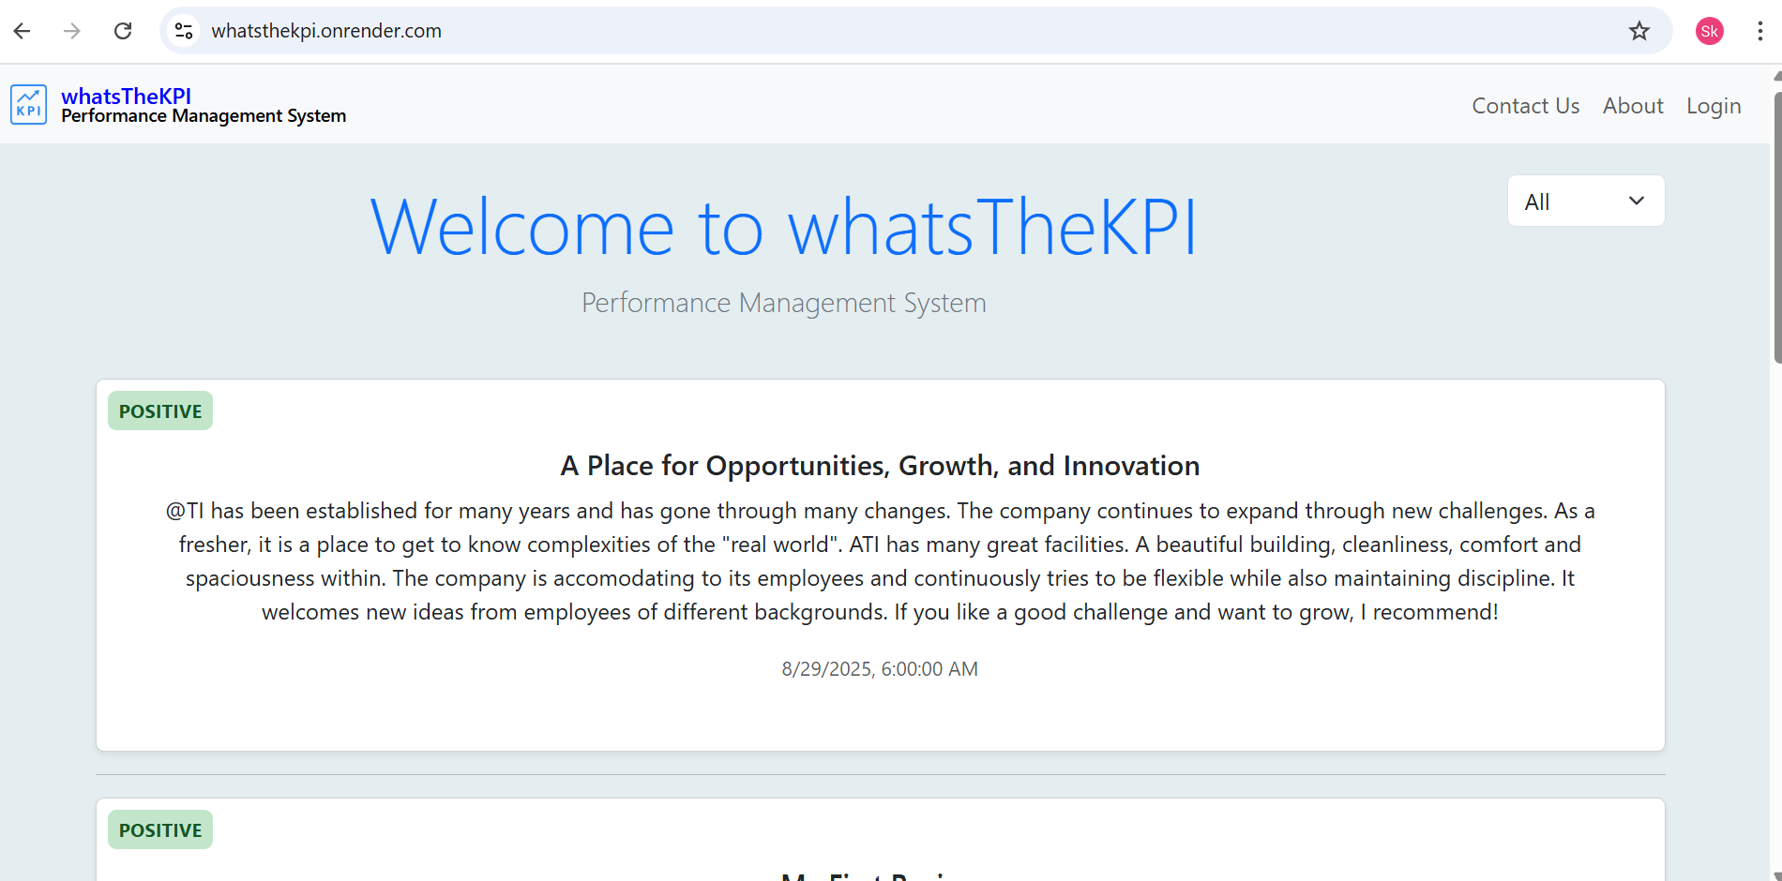

**Figure 4.1.1:** Screenshot of the Home Page.

**4.2 Admin Dashboard**

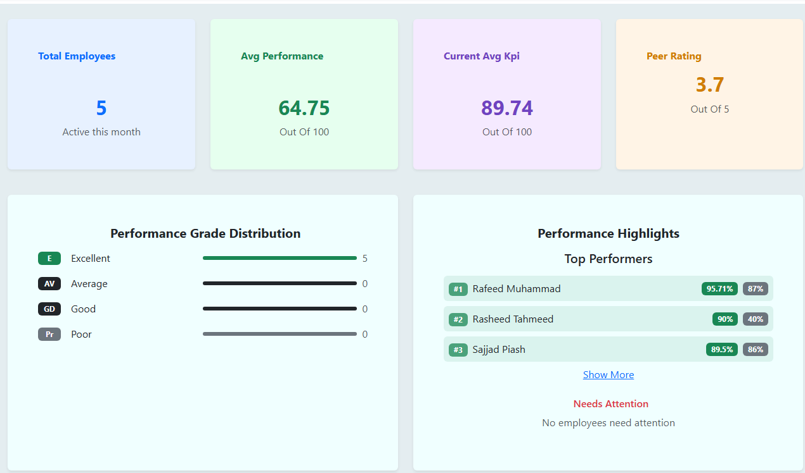

**Figure 4.2.1:** Screenshot of the Admin Dashboard.

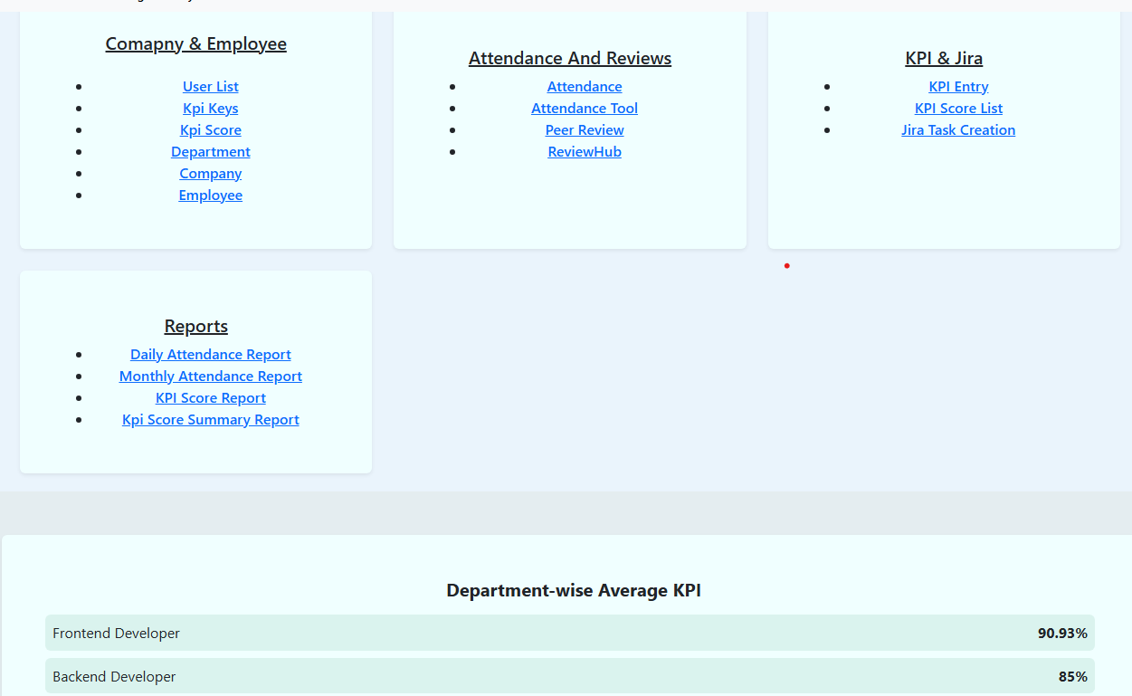

**Figure 4.2.2:** Screenshot of the Admin Dashboard.

**4.3 Company Page**

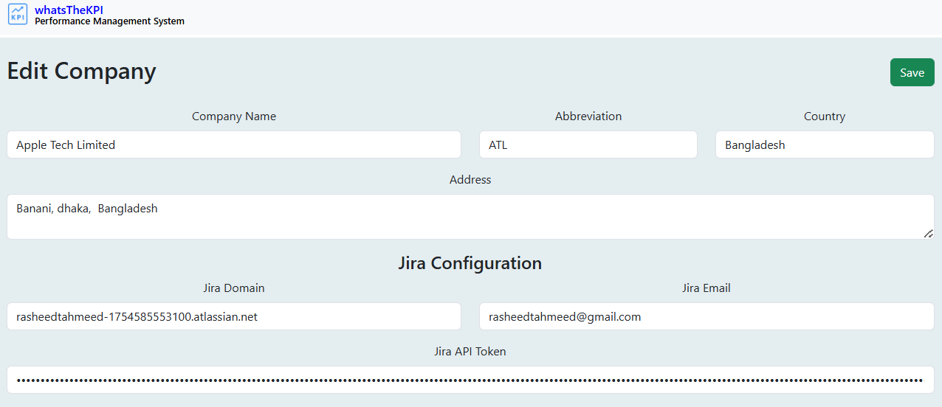

**Figure 4.3.1:** Screenshot of the Company Page.

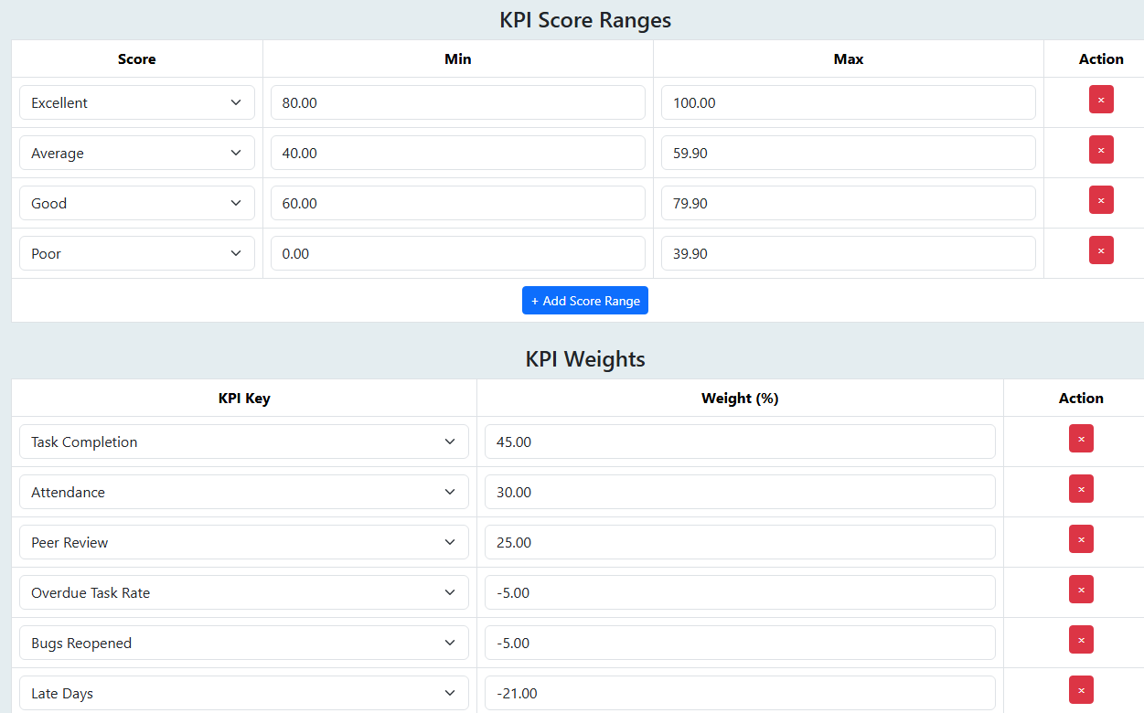

**Figure 4.3.2:** Screenshot of the Company Page.

**4.4 Employee Page**

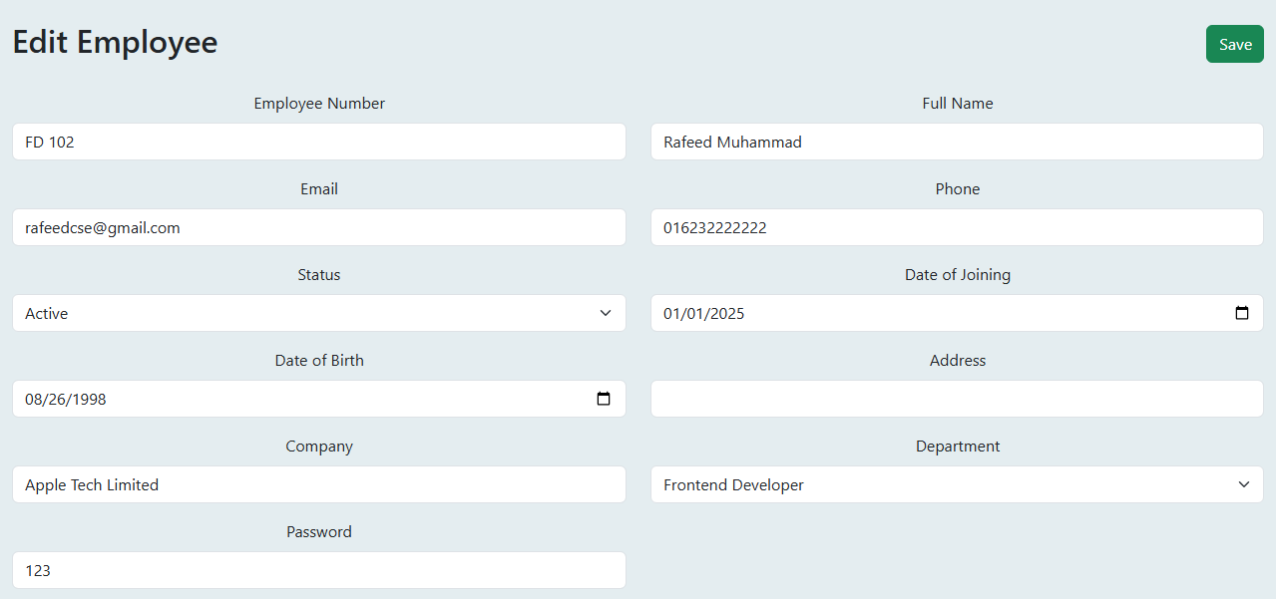

**Figure 4.4.1:** Screenshot of the Employee Page.

**4.5 KPI Entry and KPI Score List**

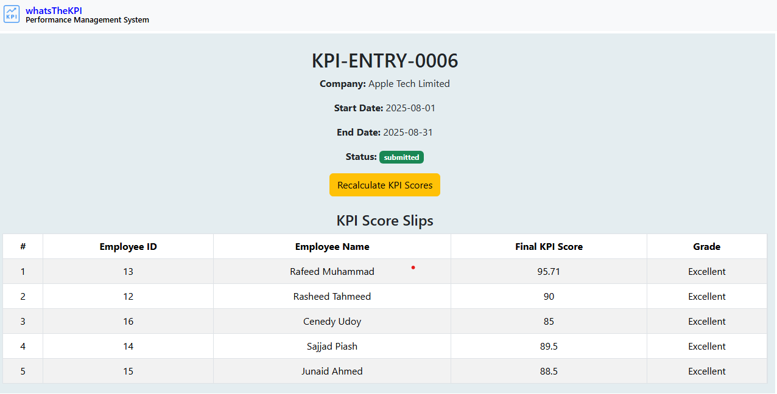

**Figure 4.5.1:** Screenshot of the KPI Entry Page.

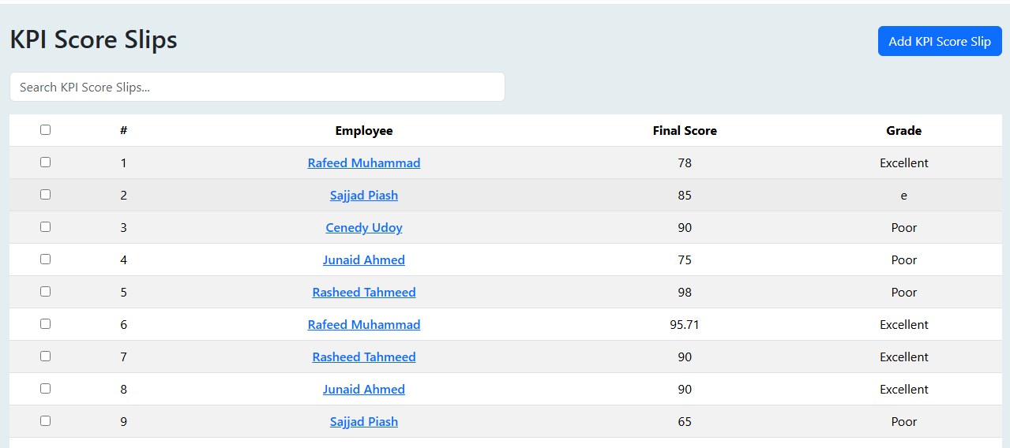

**Figure 4.5.2:** Screenshot of the KPI Score Slips.

**4.6 Attendance and Tool**

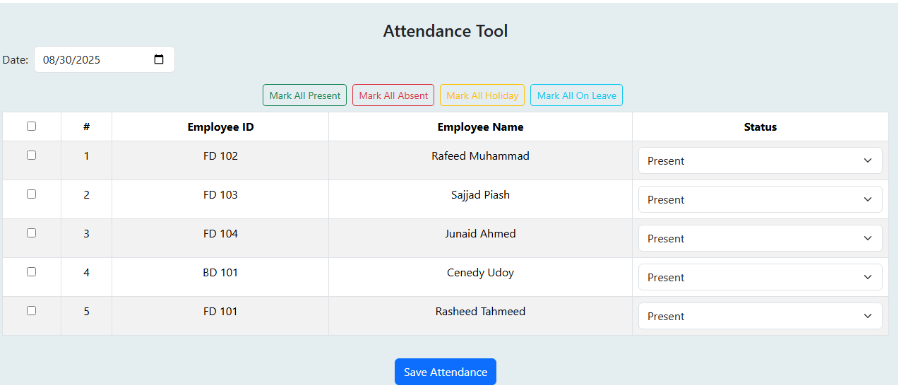  
**Figure 4.6.1:** Screenshot of the Attendance Tool Page.

**4.7 Peer Review Form**

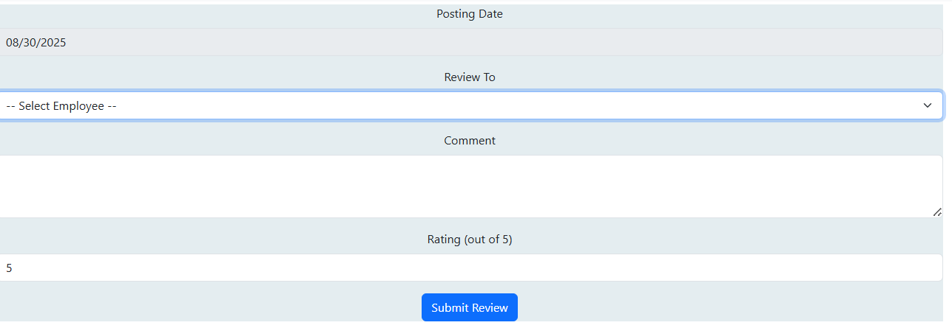

**Figure 4.7.1:** Screenshot of the Peer Review Page.

**4.8 Reports**

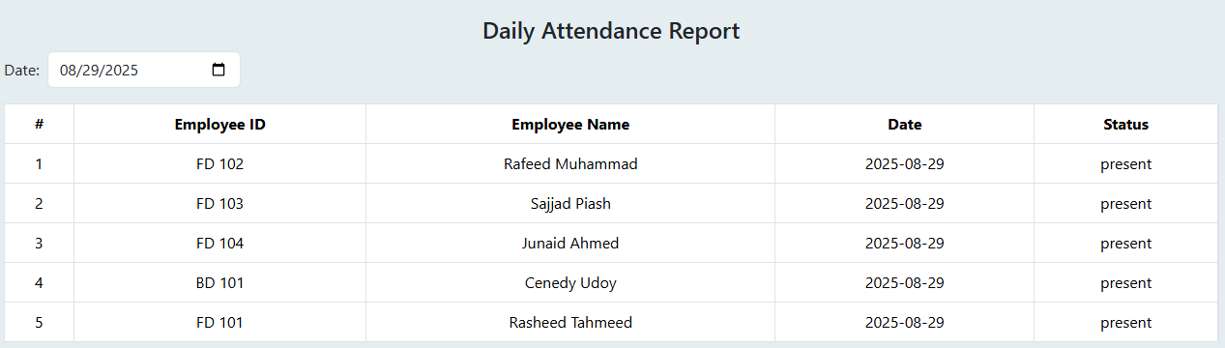

**Figure 4.8.1:** Screenshot of the Daily Attendance Report.

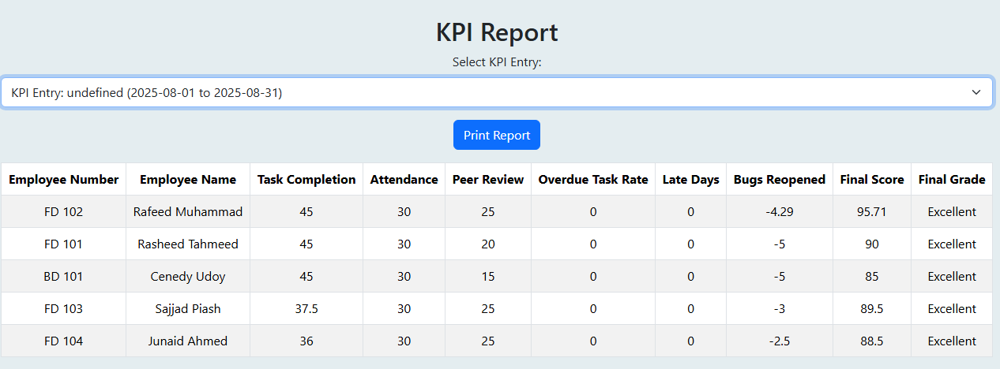

**Figure 4.8.2:** Screenshot of the KPI Score Breakdown Report.

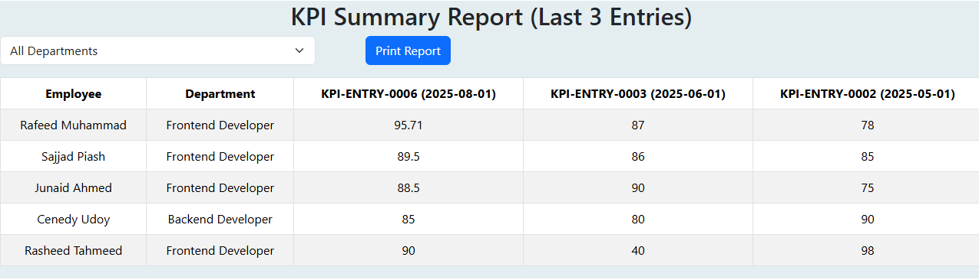

**Figure 4.8.3:** Screenshot of the KPI Summary Report.

These results and screenshots show that **WhatsTheKPI** works well to track and manage employee performance. The system is easy to use, and it helps managers and employees see how they are doing. It is ready to use and can make a real difference in keeping track of work and improving performance in a company.

**Chapter 5: System Design**

The System Design of WhatsTheKPI explains how the system is structured and how different parts work together. It includes diagrams like Use Case and ER diagrams to show user interactions, data flow, and database structure. This design ensures the system is organized, easy to maintain, and meets all functional requirements.

**5.1 Use Case Diagram**

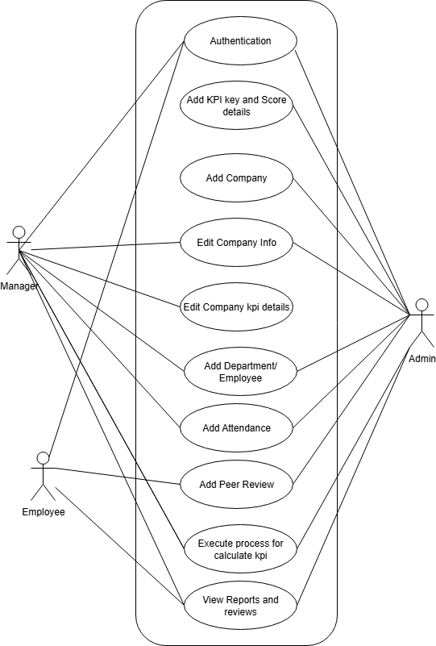

**Figure 5.1.1:** Screenshot of the Use Case Diagram

**5.2 ER Diagram**

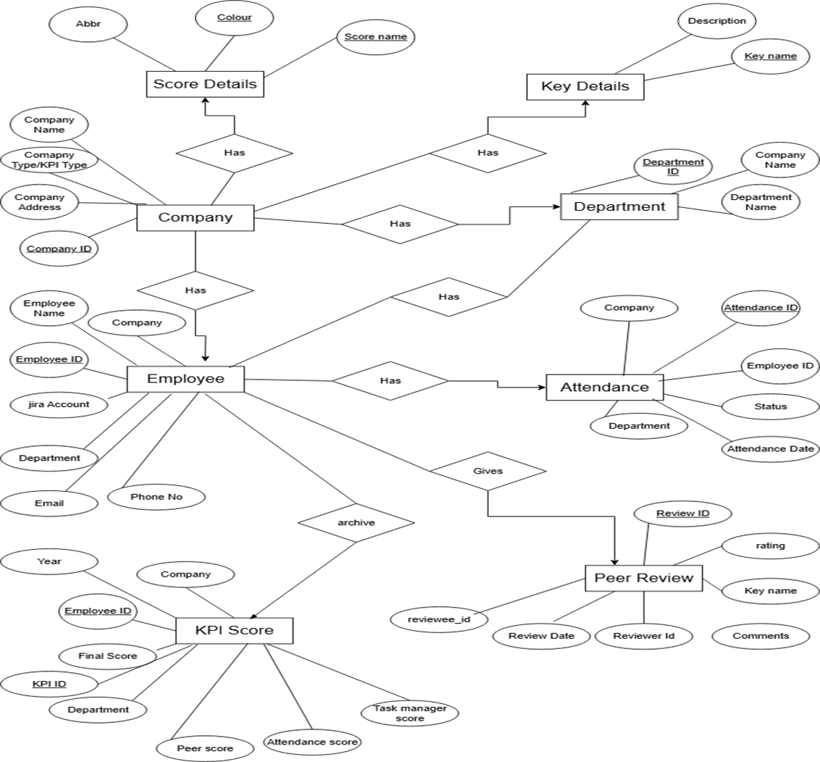

**Figure 5.2.1:** Screenshot of the ER Diagram.

**Chapter 6: Conclusion**

**6.1 Conclusion**

WhatsTheKPI shows how performance management can be improved by solving problems in KPI checking, employee feedback, and performance tracking. The platform uses features like role-based dashboards, automatic KPI report generation, peer review, Jira task assignment, and real-time analytics to make the whole process fair, clear, and on time.

The system was built step by step with testing, which made it strong and useful for admins, managers, and employees. By using modern tools like Django, React, and PostgreSQL, WhatsTheKPI is scalable, secure, and works efficiently.

Overall, this project makes KPI evaluation easier and faster, while also building a culture of accountability and transparency. It connects technology with company growth and helps both employees and organizations perform better.

**6.2 Limitations & Recommendations**

Although WhatsTheKPI achieves its main goals like calculating KPIs, tracking performance, and managing tasks, some limitations are still there. The system depends a lot on correct and timely data entry from employees and managers. If attendance, peer reviews, company reviews, or Jira tasks are not updated properly, then the KPI results may not be accurate. Users with weak internet connections may also face problems in using dashboards or getting live updates. Another limitation is that peer reviews and company reviews work best when employees actively participate, and low participation can make the evaluation less effective. Also, some users may find Jira task assignment difficult if they are not familiar with it.

#### To overcome these problems, the system can be improved by adding automated reminders for attendance, peer review, and Jira task updates, so that employees don’t forget to give data. A lighter or offline version can help people in areas with poor internet. Simple training or user guides can make Jira task assignment easier for new users. Finally, managers should encourage participation in reviews by linking them with recognition or small rewards, so employees stay active in the process. These changes will make WhatsTheKPI more accurate, user-friendly, and effective for all users.

#### **6.3 Future Works**

The scalability and adaptability of WhatsTheKPI open avenues for further enhancements to improve its impact and user experience. The following future developments are proposed:

**Predictive Analytics:** Integrate machine learning algorithms to forecast employee performance trends and identify skill gaps.

**Enhanced Jira Integration:** Extend functionality to fetch, display, and sync Jira tasks with KPI calculations for better performance tracking.

**Project Management Software Integration:** Currently, only **Jira** is integrated for task and issue tracking. Expanding integration to other performance and project management tools can further enhance workflow automation, progress tracking, and KPI evaluation efficiency.

**Attendance Integration:** Integrate and Connect Biometric device to fetch check-ins of employees automatically and process attendance using that for Accuracy and Reliability.

**HR & Payroll Integration:** Connect with payroll and HR systems to automate performance-based incentives and employee data synchronization.

**Advanced Analytics Dashboards:** Implement customizable dashboards with predictive insights, benchmarking tools, and real-time performance tracking.

**Enhanced Gamification:** Introduce team challenges, company-wide competitions, and additional recognition features to boost engagement and collaboration.

**Mobile Applications:** Develop iOS and Android apps to increase accessibility and provide push notifications for KPI updates and peer review reminders.

**Adaptive & Intelligent System:** Continuously evolve the platform to meet changing organizational needs and support strategic decision-making.

**Scalability Features & Load Balancing**: In the future, the system can be improved by adding scalability features and load balancing, so it can handle more users and higher traffic smoothly.

**Microservices Architecture:** In the future, the system can adopt a microservicesarchitecture to improve modularity, scalability, and ease of integration with other enterprise tools.

By addressing these limitations and implementing the proposed future works, WhatstheKPI can evolve into a global, transformative platform.

**References**

What is a KPI? Guide to Key Performance Indicators with Examples. [Online]. Available: <https://www.klipfolio.com/resources/articles/what-is-a-key-performance-indicator>

**Parmenter, D.** (2015). Key Performance Indicators: Developing, Implementing, and Using Winning KPIs. 3rd Edition. Hoboken: John Wiley & Sons.

**Eckerson, W. (2010).** Performance Dashboards: Measuring, Monitoring, and Managing Your Business. 2nd Edition.

**Investopedia.** (n.d.). KPIs: What Are Key Performance Indicators? Types and Examples. [Online]. Available: [https://www.investopedia.com/terms/k/kpi.asp](https://www.investopedia.com/terms/k/kpi.asp?utm_source=chatgpt.com) **[World Wide Web page]**